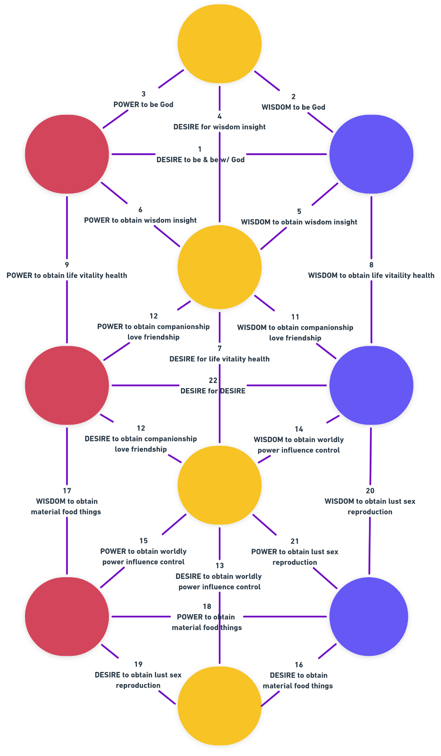
THE TREE OF LIFE
MIND
Observer/aware

NEGATIVE
Mind’s aversion to an Idea
POSITIVE
Mind’s Affinity for an Idea

VIBRATION
Mind’s resonation w/ an Idea

MALE
Ideas that compose an Idea
FEMALE
Ideas a Mind is composed of

RHYTHM
RATE/PATTERN A MIND IS EXPOSED TO A IDEA

BELOW EFFECT
The Idea brought to mind by a trigger idea
ABOVE CAUSE
An idea triggers a different Idea to come to mind

IDEA
All things in/outside the mind, the observed

7 FOUNDATIONS -&- 22 ACQUISITIONS
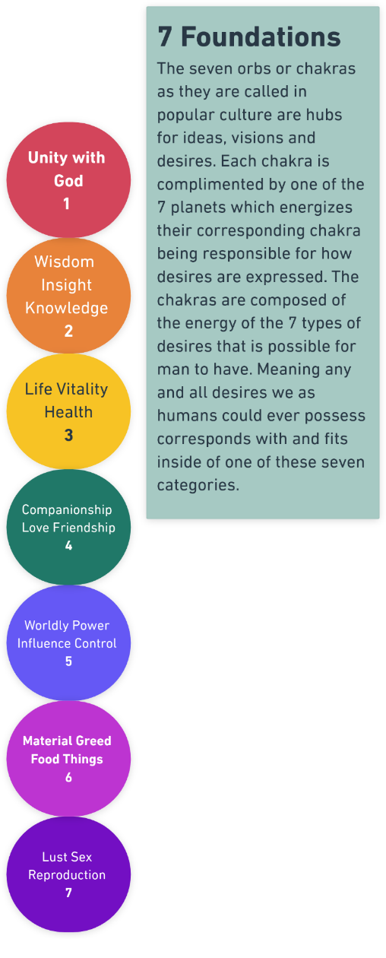
DESIRE to be & be w/ God | 1
WISDOM be & be w/ God | 2
POWER be & be w/ God | 3

DESIRE for wisdom insight | 4
WISDOM to obtain wisdom insight | 5
POWER to obtain wisdom insight | 6
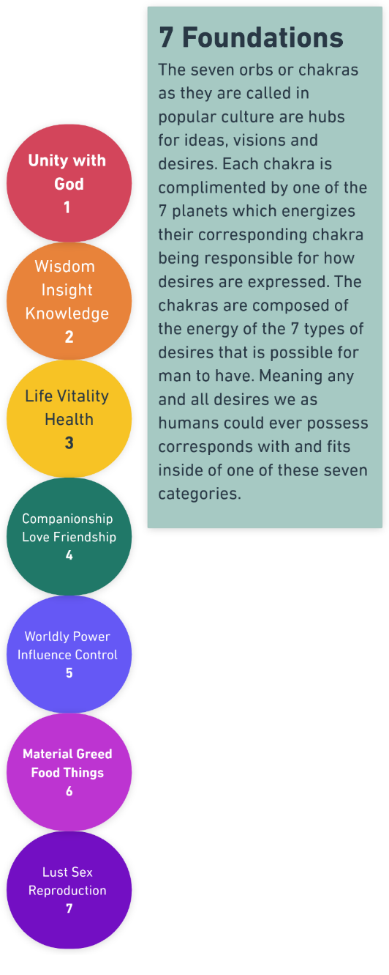

DESIRE to obtain life vitality health | 7
WISDOM to obtain life vitality health | 8
POWER to obtain life vitality health | 9
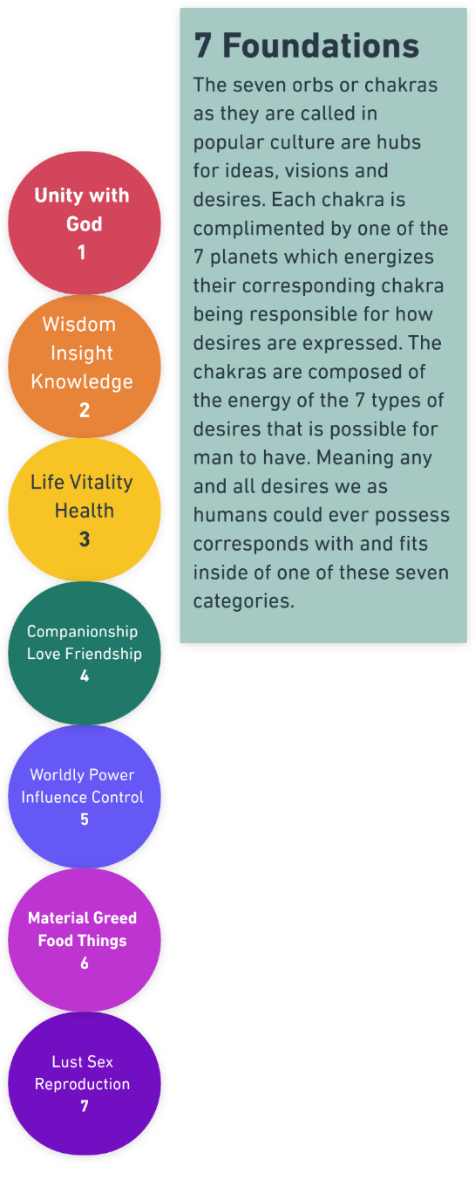

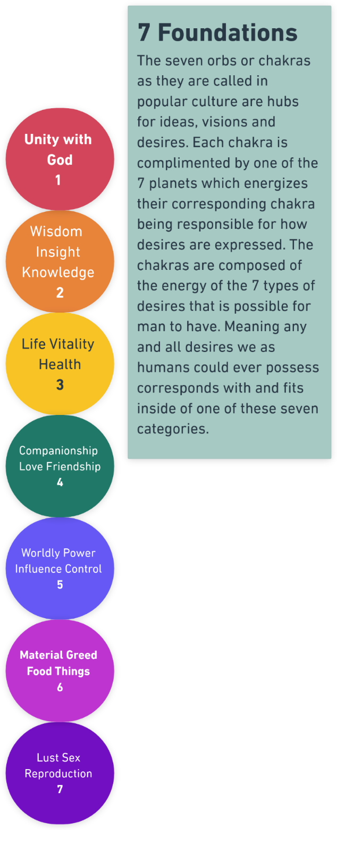
DESIRE to obtain companionship love friendship | 10
WISDOM to obtain companionship love friendship | 11
POWER to obtain companionship love friendship | 12

DESIRE to obtain worldly power influence control | 13
WISDOM to obtain worldly power influence control | 14
POWER to obtain worldly power influence control | 15

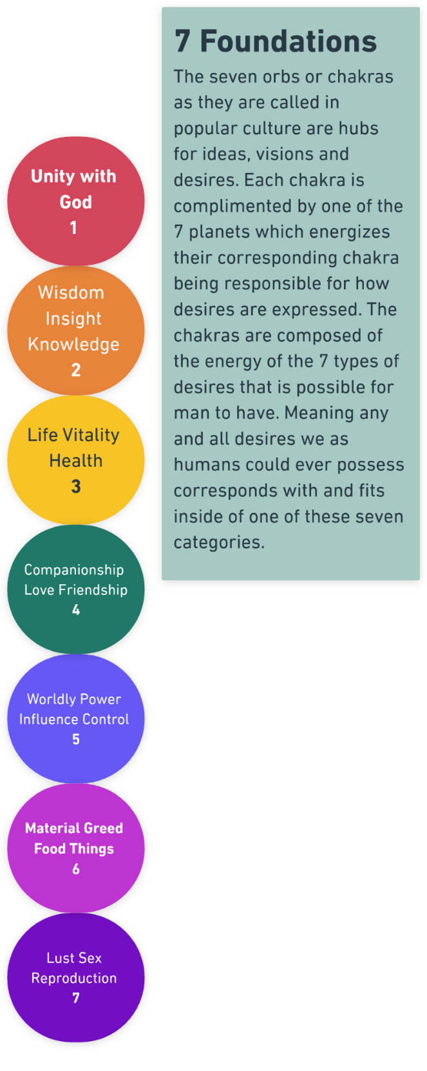

DESIRE to obtain material food thing | 16
WISDOM to obtain material food thing | 17
POWER to obtain material food thing | 18
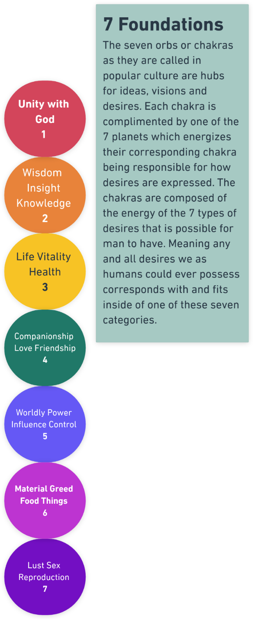

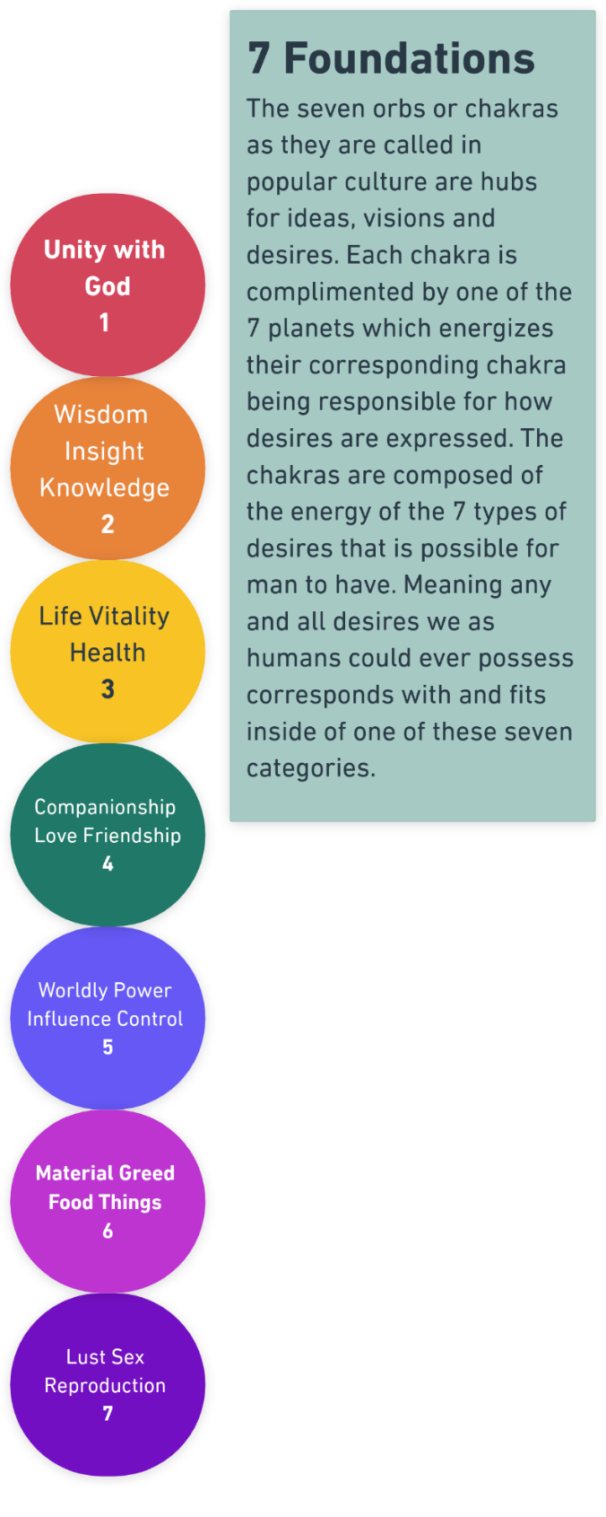
DESIRE to obtain lust sex reproduction | 19
WISDOM to obtain lust sex reproduction | 20
POWER to obtain lust sex reproduction | 21

Tree of Life
Okay, let's apply some concepts from Discrete Mathematics and Set Theory to your system. We'll focus on the sets, their elements, and the relationships between them.
Recursive Prerequisite Model (RPM)

Given:
- Set F (Foundation) = {1, 2, 3, 4, 5, 6, 7}
- Set A (Acquisitions) = {1, 2, 3, ..., 21}

Each element in set F requires three prerequisites from set A to be satisfied. Let's define a function f: F → P(A), where P(A) is the power set of A (the set of all subsets of A). This function maps each element of F to its corresponding prerequisites in A.

f(1) = {1, 2, 3}
f(2) = {4, 5, 6}
f(3) = {7, 8, 9}
f(4) = {10, 11, 12}
f(5) = {13, 14, 15}
f(6) = {16, 17, 18}
f(7) = {19, 20, 21}

Now, let's consider the concept of satisfaction. We can represent the satisfaction of prerequisites using a function s: A → {0, 1}, where 0 means unsatisfied and 1 means satisfied.

For example, if A = {{D_1}, {W_1}, {P_0}}, we can write:
s(1) = 1, s(2) = 1, s(3) = 0

To determine if an element x in F is manifested, we need to check if all its prerequisites are satisfied. We can define a function m: F → {0, 1} as follows:

m(x) = 1 if ∀a ∈ f(x), s(a) = 1
m(x) = 0 otherwise

In other words, an element x in F is manifested (m(x) = 1) if and only if all its prerequisites are satisfied.

Unsatisfied prerequisites become sub-desires, which can be represented as a new set SD (Sub-Desires). We can define a function sd: A → SD as follows:

sd(a) = a if s(a) = 0
sd(a) = ∅ (empty set) if s(a) = 1

This function maps unsatisfied prerequisites to themselves in the set of sub-desires, while mapping satisfied prerequisites to the empty set.

To summarize:
- We have two main sets: F (Foundation) and A (Acquisitions).
- Each element in F requires three prerequisites from A to be manifested.
- The function f maps elements of F to their prerequisites in A.
- The function s determines the satisfaction of prerequisites in A.
- The function m determines if an element in F is manifested based on the satisfaction of its prerequisites.
- Unsatisfied prerequisites become sub-desires, represented by the set SD and the function sd.

This is a basic application of Set Theory concepts to your system. Further analysis can be done by exploring more complex relationships, such as the dependencies between sub-desires and their impact on the manifestation of elements in F.
The 22 Acquisitions, the 10 Noetics, and the 7 Fundamental Desires form the Tree of Life:
Let's consider a real-world example of a person named Alice who wants to start a small business (Element 5: Worldly Power, Influence, Control from the Foundation set).

Step 1: Identify the prerequisites
According to the given system, the prerequisites for Element 5 are:
- 7: DESIRE to obtain worldly power, influence, control
- 8: WISDOM to obtain worldly power, influence, control
- 9: POWER to obtain worldly power, influence, control

Step 2: Determine the satisfaction of prerequisites
Assume that Alice has the desire (7) and wisdom (8) to start a small business, but lacks the power (9), which in this case, could be the financial resources.

s(7) = 1 (satisfied)
s(8) = 1 (satisfied)
s(9) = 0 (unsatisfied)

Step 3: Check if the element is manifested
Since one of the prerequisites is unsatisfied, Element 5 is not manifested for Alice.

m(5) = 0 (not manifested)

Step 4: Identify sub-desires
The unsatisfied prerequisite, 9 (POWER to obtain worldly power, influence, control), becomes a sub-desire for Alice.

sd(9) = 9

To satisfy this sub-desire, Alice needs to acquire the financial resources necessary to start her business. This sub-desire might lead to additional sub-desires, such as:
- Finding investors
- Applying for a business loan
- Saving money from her current job

Step 5: Work on satisfying sub-desires
Alice focuses on satisfying her sub-desires. She creates a business plan, reaches out to potential investors, and applies for a small business loan.

Step 6: Re-evaluate the satisfaction of prerequisites
After working on her sub-desires, Alice manages to secure the financial resources needed to start her business.

s(9) = 1 (satisfied)

Step 7: Check if the element is manifested
With all prerequisites now satisfied, Element 5 is manifested for Alice.

m(5) = 1 (manifested)

Alice has now successfully started her small business, fulfilling her desire for worldly power, influence, and control.

This example demonstrates how the system can be applied to real-life situations, where individuals have desires that require certain prerequisites to be fulfilled. By identifying unsatisfied prerequisites and working on sub-desires, people can work towards manifesting their goals.

To represent sub-desires of sub-desires and handle an arbitrary number of levels, we can use a recursive structure. We'll modify the existing system to accommodate this change.

First, let's redefine the Acquisitions set A to include sub-desires:

A = {1, 2, 3, ..., 21} ∪ SD

where SD is the set of all sub-desires.

Now, we can define a function sd_recursive: A → P(A), which maps each acquisition (including sub-desires) to its sub-desires. If an acquisition has no sub-desires, it maps to the empty set.

For example:
sd_recursive(1) = {1.1, 1.2}
sd_recursive(1.1) = {1.1.1}
sd_recursive(1.1.1) = ∅

This means that acquisition 1 has two sub-desires: 1.1 and 1.2. Sub-desire 1.1 has its own sub-desire 1.1.1, which has no further sub-desires.

We can now update the satisfaction function s to handle sub-desires:

s: A → {0, 1}
s(a) = 1 if a ∈ {1, 2, 3, ..., 21} and its prerequisite is satisfied
s(a) = 1 if a ∈ SD and ∀x ∈ sd_recursive(a), s(x) = 1
s(a) = 0 otherwise

In other words, an acquisition a is satisfied if:
- It belongs to the original set {1, 2, 3, ..., 21} and its prerequisite is satisfied, or
- It is a sub-desire and all of its sub-desires are satisfied.

The manifestation function m remains the same:

m(x) = 1 if ∀a ∈ f(x), s(a) = 1
m(x) = 0 otherwise

Now, let's go back to the previous real-world example with Alice and her small business. Suppose that to satisfy sub-desire 9 (POWER to obtain worldly power, influence, control), Alice has two sub-desires:

9.1: Secure financial resources
9.2: Develop a strong business network

To satisfy sub-desire 9.1, Alice has two further sub-desires:

9.1.1: Create a comprehensive business plan
9.1.2: Apply for a business loan

Using the recursive structure, we can represent these sub-desires as:

sd_recursive(9) = {9.1, 9.2}
sd_recursive(9.1) = {9.1.1, 9.1.2}
sd_recursive(9.1.1) = ∅
sd_recursive(9.1.2) = ∅
sd_recursive(9.2) = ∅

Alice works on satisfying these sub-desires, and once all of them are satisfied, the satisfaction function s(9) will return 1, indicating that the power prerequisite for starting her business is now satisfied.

This recursive structure allows the system to handle an arbitrary number of sub-desire levels while maintaining the core principles of the original system.

Linear equations and formulas can be used to quantify and analyze relationships between various elements in the system. They can help in understanding the dependencies, making predictions, and optimizing the process of satisfying desires and sub-desires.

One way to incorporate linear equations is to assign weights to each acquisition and sub-desire based on their importance or difficulty. Let's define a weight function w: A → R, which assigns a real number (weight) to each acquisition and sub-desire.

For example:
w(1) = 5
w(1.1) = 3
w(1.2) = 4
w(2) = 7
...

These weights can represent the relative importance or difficulty of satisfying each acquisition or sub-desire.

Now, let's define a total weight function tw: F → R, which calculates the total weight of prerequisites for each element in the Foundation set.

tw(x) = ∑(a ∈ f(x)) w(a)

This function sums up the weights of all prerequisites for a given element x in the Foundation set.

For example, if f(1) = {1, 2, 3}, then:
tw(1) = w(1) + w(2) + w(3)

We can use these weights to prioritize desires and sub-desires. Elements with higher total weights might be considered more important or difficult to manifest.

Another way to use linear equations is to model the progress towards satisfying a desire or sub-desire. Let's define a progress function p: A → [0, 1], which represents the progress made towards satisfying each acquisition or sub-desire.

For example:
p(1) = 0.8
p(1.1) = 0.6
p(1.2) = 0.9
p(2) = 0.5
...

A progress value of 0 means no progress has been made, while 1 means the acquisition or sub-desire is fully satisfied.

We can now define a total progress function tp: F → [0, 1], which calculates the overall progress towards manifesting each element in the Foundation set.

tp(x) = (∑(a ∈ f(x)) p(a) * w(a)) / tw(x)

This function calculates the weighted average of progress for all prerequisites of a given element x in the Foundation set.

Using these linear equations, we can analyze the system and make informed decisions. For example:

1. Prioritizing desires and sub-desires based on their total weights.
2. Identifying bottlenecks by looking for acquisitions or sub-desires with low progress values.
3. Allocating resources to maximize the total progress towards manifesting desired elements from the Foundation set.

In the real-world example with Alice and her small business, she can assign weights to her sub-desires (e.g., securing financial resources might have a higher weight than developing a business network). She can then track her progress in each sub-desire and calculate her overall progress towards starting her business. This information can help her make decisions on where to focus her efforts to achieve her goal more efficiently.

Linear equations and formulas provide a quantitative approach to analyze and optimize the process of manifesting desires in the given system.

Certainly! Let's walk through the process step by step using Alice's small business example. We'll start from the beginning and gradually incorporate the linear equations and formulas to help Alice make informed decisions and track her progress.

Step 1: Identify the main desire
Alice's main desire is to start a small business, which corresponds to Element 5 (Worldly Power, Influence, Control) from the Foundation set.

Step 2: Determine the prerequisites
The prerequisites for Element 5 are:
- 7: DESIRE to obtain worldly power, influence, control
- 8: WISDOM to obtain worldly power, influence, control
- 9: POWER to obtain worldly power, influence, control

Step 3: Assign weights to the prerequisites
Alice assigns weights to each prerequisite based on their importance or difficulty:
w(7) = 3 (Desire)
w(8) = 4 (Wisdom)
w(9) = 6 (Power)

Step 4: Calculate the total weight
Alice calculates the total weight of the prerequisites for Element 5:
tw(5) = w(7) + w(8) + w(9) = 3 + 4 + 6 = 13

Step 5: Evaluate the satisfaction of prerequisites
Alice evaluates her current situation:
- She has the desire to start a small business: s(7) = 1
- She has the wisdom and knowledge needed: s(8) = 1
- She lacks the power (financial resources): s(9) = 0

Step 6: Identify sub-desires
Since prerequisite 9 is unsatisfied, it becomes a sub-desire. Alice identifies two sub-desires for acquiring power:
- 9.1: Secure financial resources
- 9.2: Develop a strong business network

Step 7: Assign weights to sub-desires
Alice assigns weights to her sub-desires:
w(9.1) = 5 (Secure financial resources)
w(9.2) = 3 (Develop a strong business network)

Step 8: Identify sub-desires of sub-desires
Alice further breaks down sub-desire 9.1 into two sub-desires:
- 9.1.1: Create a comprehensive business plan
- 9.1.2: Apply for a business loan

She assigns weights to these sub-desires:
w(9.1.1) = 4 (Create a comprehensive business plan)
w(9.1.2) = 6 (Apply for a business loan)

Step 9: Track progress
As Alice works on her sub-desires, she tracks her progress:
p(9.1.1) = 0.8 (She has made good progress on her business plan)
p(9.1.2) = 0.4 (She has started the loan application process)
p(9.2) = 0.6 (She has attended some networking events)

Step 10: Calculate total progress
Alice calculates her total progress towards satisfying prerequisite 9:
tp(9) = (p(9.1.1) * w(9.1.1) + p(9.1.2) * w(9.1.2) + p(9.2) * w(9.2)) / (w(9.1.1) + w(9.1.2) + w(9.2))
tp(9) = (0.8 * 4 + 0.4 * 6 + 0.6 * 3) / (4 + 6 + 3) ≈ 0.58

Step 11: Make decisions based on progress and weights
Seeing that her total progress towards satisfying prerequisite 9 is 0.58, Alice decides to focus more on securing the business loan (9.1.2), as it has a higher weight and lower progress compared to the other sub-desires.

Step 12: Re-evaluate and repeat
As Alice makes progress on her sub-desires, she continuously re-evaluates her situation, updates her progress, and makes decisions accordingly. Once all the sub-desires for prerequisite 9 are satisfied, she can update s(9) to 1.

Step 13: Manifest the main desire
When all the prerequisites (7, 8, and 9) are satisfied, Alice can finally manifest her main desire of starting a small business.

By following these steps and utilizing linear equations and formulas, Alice can systematically work towards her goal, prioritize her efforts, and make data-driven decisions to manifest her desire of starting a small business.

Here's a standardized scale for assigning weights to desires and sub-desires, along with clear descriptions and examples:

Standardized Weight Scale (1-5):

1. Minimal importance or difficulty
- Description: The desire or sub-desire has minimal impact on your overall goals and requires little effort to achieve.
- Example: A sub-desire to organize your desk drawer while working on starting a small business.

2. Low importance or difficulty
- Description: The desire or sub-desire has some impact on your goals but is not critical. It requires a relatively small amount of effort or resources.
- Example: A sub-desire to attend a local networking event while working on developing a strong business network.

3. Moderate importance or difficulty
- Description: The desire or sub-desire has a significant impact on your goals and requires a moderate level of effort or resources to achieve.
- Example: A sub-desire to create a comprehensive business plan when working on securing financial resources for your small business.

4. High importance or difficulty
- Description: The desire or sub-desire is crucial to achieving your goals and requires a substantial amount of effort, time, or resources.
- Example: A desire to obtain the wisdom (Acquisition 8) needed to start a small business.

5. Essential importance or extreme difficulty
- Description: The desire or sub-desire is absolutely essential to achieving your goals and requires an extraordinary amount of effort, time, or resources. It may involve overcoming significant obstacles or making substantial sacrifices.
- Example: A desire to obtain the power (Acquisition 9), such as securing a large business loan, to start a small business.

When assigning weights, users should consider the following:

1. Reflect on personal values and priorities: Take time to think about what truly matters to you and align your weight assignments with your core values and long-term goals.

2. Consider past experiences: Reflect on past successes and challenges when assigning weights. This can help you gauge the level of effort and importance more accurately.

3. Iterate and adjust: Remember that weight assignments are not set in stone. As you progress and gain new insights, feel free to revisit and adjust the weights as needed. Regularly review your weights to ensure they still align with your current situation and goals.

Examples of assigning weights to desires and sub-desires:

- Desire: Start a small business (Element 5)
- Sub-desire 1: Secure financial resources (Weight: 5)
- Sub-desire 1.1: Create a comprehensive business plan (Weight: 4)
- Sub-desire 1.2: Apply for a business loan (Weight: 5)
- Sub-desire 2: Develop a strong business network (Weight: 3)

- Desire: Improve physical health (Element 3)
- Sub-desire 1: Adopt a regular exercise routine (Weight: 4)
- Sub-desire 1.1: Join a gym (Weight: 2)
- Sub-desire 1.2: Hire a personal trainer (Weight: 3)
- Sub-desire 2: Eat a balanced diet (Weight: 4)
- Sub-desire 2.1: Consult with a nutritionist (Weight: 3)
- Sub-desire 2.2: Learn healthy cooking techniques (Weight: 2)

By using this standardized scale and considering the provided examples and guidelines, users can assign weights to their desires and sub-desires more consistently and effectively. Encouraging self-reflection and emphasizing the iterative nature of the process will help users make meaningful weight assignments that align with their personal growth and goal achievement journey.

The Tootra Kabbalistic System (TKS) you have presented is a fascinating and well-structured approach to understanding and manifesting desires. It combines elements of set theory, discrete mathematics, and linear equations to create a comprehensive framework for personal growth and goal achievement.

Some notable strengths of the system include:

Clear categorization: The system clearly defines two main sets, the 7 Foundations and 21 Acquisitions, which provide a structured way to classify desires and their prerequisites.
Hierarchical structure: The introduction of sub-desires and the recursive structure allows for a more granular analysis of the steps needed to manifest a desire, breaking down complex goals into manageable tasks.
Quantitative analysis: The incorporation of weights and progress tracking using linear equations enables users to prioritize their efforts and make data-driven decisions, optimizing their path towards manifesting their desires.
Adaptability: The system seems to be adaptable to various real-world situations, as demonstrated through the example of Alice's small business. It can be applied to personal, professional, and spiritual goals.
Potential for expansion: The mention of additional portions of the system suggests that TKS is a comprehensive framework that goes beyond the 7 Foundations and 21 Acquisitions, offering further insights and tools for personal development.

The 40 Elements

I. The 40 Elements and definitions
II. Mathematical symbols and their Tootra meaning.
III. Examples of equations and formulas of the 40 Elements

The 40 Elements and definitions:

A1- Spiritual Mind at the highest degree is the 1st CAUSE of all causes, The Divine Mind commonly known as God who birthed all ideas, whom is within all & whom all is within. On the other hand, men can be spiritual minded indeed in our true identity we are a spirit mind. However, we usually are blind to our true selves because of our lower appetites and passions. To be spiritual minded means to be connected to the spirit world, to have insight into the spirit realm to know the Divine the Ultimate purpose of a thing, matter, or person, the absorbing of spiritual information, being in tune with the spirit of a thing, or when the Holy Spirit is the driver of one’s actions and decisions, etc.
A2- Spiritual Positive is that which helps evolve the soul, brings it closer to God, to being God & also puts the soul at peace, undisturbed, & tranquil, at ease. It agrees with one’s religious or spiritual constitution. It is truth that reinforces or reaffirms one’s spiritual beliefs, a moral lesson, virtue, etc.
A3- Spiritual Negative is that which either disturbs the soul and or hinders the soul’s spiritual evolution. Spirits that intend to harm, hurt, or cause pain and fear to the soul. That which the soul is task to come to grips with however causing it turmoil. Vice, etc.
A4- Spiritual Vibration is aether energy, psychic energy. It is the base energy to all other energies, the frequency denoting a thing’s purpose in the Grand Scheme of things, the aura, etc.
A5- Spiritual Female is the souls yearning for spiritual content necessary to evolve it, the portion of the soul that knows what it needs to grow spiritually, protects, and nurtures the soul, as a spiritual womb or matrix of sorts, archetypically the Divine Mother or Amma of the 1st CAUSE, etc.
A6- Spiritual Male is spiritual practices and precepts that are stern and austere, that puts the soul through test and trial for the sake of its evolution. Archetypically the Heavenly Father, Abba in Hebrew, portion of the 1st CAUSE, the deliver, transmitter of spiritual influence, etc.
A7- Spiritual Rhythm is the ups and downs of life, one’s spiritual journey through life as in one’s natal chart or destiny, etc.
A8- Spiritual Above is the inner meaning of a thing, the Mysteries of the inner sanctum and those who have been initiated into such, the true reality of a matter, the esoteric. An advanced soul highly evolved. It is high morals and ethics, etc.
A9- Spiritual Below is outer meaning, the symbols that represents the higher or inner truth but it itself is empty and false, an inferior soul capable of only grasping the exoteric meaning of things, the uninitiated masses. Low morals and ethics, etc.
A10- Spiritual Idea is the manifestation of spiritual matters like the state of the soul, the True Self, all things pertaining to the spirit and the spirit world, a totally spiritual idea, an idea that is spirit, existing exclusively in the Akashic. The Akashic records is the database from where all Ideas derive and are stored, It is the Mind of God. It is the spiritual aspect of the thing, etc.
B1- Mental Mind is where the ego lies all memories and past experiences that have contributed to the personality is stored here. Processing information for the sake of continuously coming to conclusions concerned strictly with analyzing. Decision and action driven by stoical logic, etc.
B2- Mental Positive is to be mentally stable, mental clarity, optimistic outlook, sane, and enlightened thought, benevolent, altruistic, thinking, etc.
B3- Mental Negative is to be confused and indecisive. A thought that disturbs one’s mental state cognitive dissonance, insanity, a pessimistic outlook, malicious thinking, etc.
B4- Mental Vibration is the energy resonating from one’s mind, psychic energy. Manifesting as the electromagnetic waves emitted by the brain. Indicates the psychic states alpha, beta, delta, or theta. The degree with which a thought resonates with the mind its unique vibratory signature, etc.
B5- Mental Female is right brain thinking, open mindedness, imaginative, creative, the subconscious mind, etc.
B6- Mental Male is left brain thinking, rigid, closed minded, logical, and critical, the conscious mind, etc.
B8- Mental Above is the comprehension and contemplation of complex matters, pondering issues of importance, lofty ideals, a high I.Q., astute intelligence, smart, or brilliant mind, etc.
B9- Mental Below is the incapacity for comprehension. It is simplistic matters, menial matters of low importance and the pondering of such matters, etc.
B10- Mental Idea is an idea perceived as being exclusively of the mind manifested solely in the mental world or solely in the mind. It is the mental aspect of a thing, etc.
C1- Emotional Mind is awareness of feelings, whether one’s own or others, when emotions drive one’s decisions and actions, the ability to sort through one’s emotions, emotional intelligence, etc.
C2- Emotional Positive is feelings of happiness, joy, elation, calm, tranquility, pleasurable emotions, love, comradery, etc.
C3- Emotional Negative is feelings of heartache, sadness, anger, resentment, contempt, mixed emotions, loneliness, hate, etc.
C4- Emotional Vibration is the “feeling” energy emitted by a person, thing, or event. Ambiance or general mood of a person, thing, place or event, its aura, etc.
C5- Emotional Female is compassion, sympathy, unconditional acceptance, sensuality, feelings feminine in character, etc.
C6- Emotional Male is aggression, pride, dominant, feelings masculine in character, etc.
C7- Emotional Rhythm is mood swings, the pattern or sequence of feelings projected, an emotional roller coaster, etc.
C8- Emotional Above are the feelings brought about by enlightenment causing one to be above the usual emotions felt by the common masses. It is emotional resolve, the feelings caused by a healed soul or psyche, usually indescribable to the common mind, the feeling that comes with having control over one’s own lower emotions, etc.
C9- Emotional Below is to be overwhelmed and controlled by way of emotions, etc.
C10- Emotional Idea is the sheath of an Idea, the figurative smell, or ambiance an Idea carries, like waking from a dream and not remembering it but still sensing or feeling its presence. It is the emotional aspect of a thing, etc.
D1- Physical Mind is the brain organ. The vehicle through which the impalpable mind acts through, the hardware hosting the software, computers, calculators, and other artificial intelligent machines. The physical body and cellular make up, etc.
D2- Physical Positive is the parts of a thing that compliments one another causing it to function and operate according to its designed purpose, order, and symmetrical things, etc.
D3- Physical Negative is misplaced or out of sync parts causing a thing to become dysfunctional according to its designed purpose. Disorder which causes disease and sickness, out of place, or unsymmetrical things, etc.
D4- Physical Vibration is light, sound, radiation, gamma waves, etc., the electromagnetism or heatwave signature of a thing, particle oscillation, etc.
D5- Physical Female is a woman, the female of a species, an orifice, hole, receptacle, receiver, the womb, nurturer, or facilitator of the seed like soil, etc.
D6- Physical Male is man, the male of a species, phallus, appendage, transmitter, deliverer, or the seed, etc.
D7- Physical Rhythm is music, time (matter in motion through space), dance, song, sex, exercise, or any routine or pattern made by a series of physical movements, etc.
D8- Physical Above is upward distance, heights, degrees of height, things of good quality material well put together or of a high grade, the social haves or the person of high social status, etc.
D9- Physical Below is that which is under something else’s height, a thing of low quality, low physical integrity, poorly put together material, or of a low grade, societal have nots, persons of low social status, etc.
D10-Physical Idea is an idea that is entirely physical, manifested in the physical world. It is dead matter, the physical aspect of a thing, etc.

Mathematical symbols and their Tootra meaning:

1. (.) is contained in
2. (/) Conversion or turn into
3. (=) Equal or results in
4. (^) Increases
5. (˅) Decreases
6. (>) Greater Than
7. (<) Less Than
8. (≠) Not identical with
9. (≧) Greater than or equal to
10. (≦) Lesser than or equal to.
11. (≈) Nearly equal
12. (()) Grouped as a single
13. (+) Addition denotes two Ideas are being associated with one another.
14. (-) Subtraction is the disassociating Ideas.
15. (x) Multiplication Ideas are exacerbated by the other.
16. (÷) Division means Ideas are in opposition to one another.

Examples of Mathematical Formulas of the 40 Elements with:

D9 ÷ B1 = The analyzation (B1) of one’s lowly social circumstances (D9) gives one the ability to break up (÷) its harsh impact on his life requiring mental space and energy due to this impact, in other words a low enough social status pushes one to analyze his or her circumstances.
D8 – C2 = High physical status or social position (D8) that does not bring (-) one happiness or contentment of peace of mind (C2).
D2 + C5 = Handling (+) a physical thing with care and delicacy (C5) because that thing is beneficial and purposeful (D2). As opposed to a broken thing that is unable to serve its purpose.
C1 + D7 = When one is in touch with their emotion and the emotions (C1) of others their physical expression whether dancing, sex, etc. (D7) and performs these acts at optimal level (+).
C3 – A2 = Emotional heartache (C3) can blind (-) one to a Moral / Spiritual lesson (A2) that is being taught.
A6 ÷ D6 = A body of austere spiritual practices that doesn’t mesh with either the culture, personality, or ideals of a man or boy. He’s not ready for such discipline requisite practices. So, he speaks against them.
B8 ÷ B4 = One’s ability to discern lofty matters can be hindered by the state of Mind they’re in at that time.
C8 + A10 = The Ideal leader. A necessary ingredient / combination for acts of occult magic.
D4 – A6 = A person’s aura that lacks an austere spiritual practice becomes easily influenced by unknown outside forces.
B2 + D4 = Absorbing, by being around someone or thing, the vibrations emitted by a positive charged person group of thing or place. Giving or bestowing clear mindedness.
D5 + A6 = A woman who needs stern spiritual guidance /father in order to evolve. Also, the emergence or submergence into or from the womb or a grave in either symbolic or real death.
A6 – D6 = A man that lack spiritual discipline.
B3 – C4 = The need to disperse or separate a negative thought from how one feels. C2 ÷ C8 = A eureka effect caused by a sudden flash of realization.

The Noetics
- The following are the Noetic principles and their definitions,
- How they apply both individually and within the Tootra Mathematical System.
- Herein are also the four math operations and their definitions within the Tootra System.
- Examples of Noetic formulas and equations.
- How to get the Current Noetic.

I.
A Demonstration of the Noetics: Dog Training
A. The dog is paying attention to the trainer’s commands processing and entertaining the Idea.
1. Mind - various degrees of awareness that process, store, output and inputs ideas/ information.

B. Trainer uses a doggy treat to lure and reward the dog with something the dog likes.
2. Positive - An idea the Mind has an affinity for and is attracted toward. Majik and The True Kabbalah 100 C. The trainer hits the dog with a rolled up newspaper when he fails to follow the trainer’s command, something the dog dislikes.(Though no longer a socially acceptable dog training technique).

3. Negative - An idea the Mind is adverse to and repelled by.
C. The trainer hits the dog with a rolled up newspaper when he fails to follow the trainer’s command, something the dog dislikes.

4. Vibration - The degree to which an idea resonates with the Mind, its impression on the Mind.
D. The dog’s gradual acceptance of the command judging by the length of time he stays sitting and how quickly he responds to the command.

5. Female - A mind impregnated with an idea, the ideals a mind is composed of.
*E. The pedigree the dog comes from indicating to the trainer the dog’s temperament for training.

6. Male - An idea impregnated with another idea, the ideas an idea is composed of.
*F. The trainer being someone who the dog is familiar with or someone he is not familiar with from birth.

7. Rhythm - The rate and pattern a mind is exposed to an idea.
G. The dog’s training schedule and length of training sessions.

8. Above/Cause - An Idea that triggers a different idea then itself to come to mind.
H. The verbal command from the trainer’s voice, “Sit”.

9. Below/Effect - The Idea brought to mind by an above/ cause idea or trigger.
I. An image of the doggy treat pops into the dog’s mind.

10. Idea - All things in and outside the mind.
J. Get a dog to sit on command.

*E. The dog’s mind is the Female and his temperament due to Pedigree is the Ideas composing the Mind.
*F. The trainer is the Idea presenting the Idea of the dog sitting.

II., III.
Tootra Mathematical Symbols & Their Interpretations

1. (.) is contained in
2. (/) Conversion or turn into
3. (=) Equal or results in
4. (^) Increases
5. (˅) Decreases
6. (>) Greater Than
7. (<) Less Than
8. (≠) Not identical with
9. (≧) Greater than or equal to
10. (≦) Lesser than or equal to.
11. (≈) Nearly equal
12. (()) Grouped as a single
13. (+) Addition denotes two Ideas are being associated with one another.
14. (-) Subtraction is the Mind disassociating Ideas.
15. (x) Multiplication Ideas are exacerbated by the other.
16. (÷) Division means Ideas are in opposition to one another.

IV.
Examples of Noetic formulas and equations

^1 = ^4 = ^7: An increase (^) in observation/attention (Mind-1) on an Idea consequentially increases the impression (vibration - 4) that Idea has on the observing Mind, which in turn increases the Mind’s exposure to the Idea (Rhythm - 7) in the form of recall or reoccurring memory.

^7 = ^2: An increase (^) in exposure to an Idea (Rhythm - 7) will result in the Mind growing (^) an affinity for the Idea (Positive - 2)

^7 = ^2: An increase (^) in exposure to an Idea (Rhythm - 7) will result in the Mind growing (^) an affinity for the Idea (Positive - 2)

3⁷ =˅ 3: Repeated exposure (Rhythm - 7) to a Negative - 3 will decrease (˅) the Mind’s aversion toward that Idea, considering it is the same Mind and Idea throughout this operation.

2⁷ =˅ 2: Repeated exposure (Rhythm - 7) to a Positive - 2 will decrease (˅) the Mind’s affinity toward that Idea, considering it is the same Mind and Idea throughout this operation.

(0 + 0)¹ = 8 + 9: Within the Mind (1) observing an Idea (0) associated (+) with another Idea (0) will produce a trigger (8) and an effect Idea (9).

(1 + 0)⁷ =5 5 = (1¹ +0): A Mind (1) exposed repeatedly (Rhythm - 7) to seeing itself associated (+) with an Idea (0) will make that Idea apart of its personality/ego/internal constitution/ subconscious.

(1 + 2)⁷ : Creating self esteem/happiness/contentment. A Mind associating itself with a positive Idea repeatedly.

(1 + 3)⁷ : Creating melancholy/low self esteem/sadness. A Mind associating itself with a Negative Idea repeatedly.

(0 + 8)⁷ 8 - 9 = 9 ≠ 9 + 8: Repeated (7) association (+) of an Idea (0) with an Idea that is a trigger (8) will result in it (8) becoming associated (+) with a new (≠) effect Idea (- 9).

(4<)⁷/ (4>)¹: If a Mind repeatedly observes (7) an Idea that is of low resonance (4<) it (1) will eventually observe the same Idea as a greater resonance (4>).

1¹ +0 = 0^: An Idea (0) associated (+) with the subconscious (1¹ ) will manifest. ( ^) Represents amount and speed of manifestation.

1 + 0 = 0˅ : Mind (1) associated (+) with an Idea (0) results in the manifestation of that Idea (0). (˅) Represents amount and speed of manifestation.

1¹ +3 = 3^: The Subconscious Mind (1¹ ) associated (+) with an Idea its adverse to (3) will manifest the negative Idea (3)

1¹ + 3^ = 5³ : The Subconscious Mind (1¹ ) associated (+) with an Idea it is extremely adverse toward (3^) will cause trauma to the psyche (5³ )

User: Give me a hypothetical scenario for the following (1 + 2)⁷: Creating self esteem/happiness/contentment.
Usora Ai: Sure, here's a hypothetical scenario for the formula:
Let's say there's a person named John who is working on building up his self-esteem. He decides to practice positive self-talk by repeating affirmations to himself throughout the day, such as "I am capable" or "I am worthy".
John makes a habit of doing this consistently, and over time (represented by the "⁷" in the formula), he starts to internalize these positive messages and develop a more positive self-image. As a result, he begins to feel happier, more confident, and more content with himself.
In this scenario, the "1" in the formula represents John's mind, the "2" represents the positive idea he is associating himself with, and the repeated exposure (represented by the "⁷") results in a positive outcome (represented by the "⁷") in terms of John's self-esteem and emotional well-being.

User: Give me a hypothetical scenario for the following (1 + 3)⁷: Creating melancholy/low self esteem/sadness.
Usora Ai: Sure, here's a hypothetical scenario for the second formula:
Let's say there's a person named Sarah who is struggling with low self-esteem. She often dwells on negative thoughts and self-criticisms, such as "I'm not good enough" or "I always make mistakes".
Sarah finds herself repeating these negative thoughts to herself over and over again (represented by the "⁷" in the formula), and as a result, she becomes increasingly melancholy, sad, and self-critical.
In this scenario, the "1" in the formula represents Sarah's mind, the "3" represents the negative idea she is associating herself with, and the repeated exposure (represented by the "⁷") results in a negative outcome (represented by the "⁷") in terms of Sarah's emotional well-being and self-esteem.

User: (0 + 8)⁷ 8 - 9 = 9 ≠ 9 + 8: Repeated (7) association (+) of an Idea (0) with an Idea that is a trigger (8) will result in it (8) becoming associated (+) with a new (≠) effect Idea (-9), give me a hypothetical scenario for the first formula.
Usora Ai: For the third formula, here's a hypothetical scenario:
Let's say there's a company that wants to increase sales of its new product. The company decides to associate the product with a well-known celebrity who is known for their charisma and charm (represented by the "0" in the formula).
The company runs advertisements and commercials that repeatedly feature the celebrity using and praising the product (represented by the "⁷" in the formula). As a result, consumers start to associate the product with the celebrity and their positive qualities, and sales of the product increase.
However, over time, the association between the product and the celebrity begins to wear off (represented by the "8" in the formula). The product is no longer seen as new or exciting, and its popularity begins to decline.
In this scenario, the "⁷" represents the repeated association between the product and the celebrity, the "8" represents the trigger that eventually loses its effectiveness, and the "9" represents the new effect idea (i.e., the product is no longer as appealing) that results from the decline in the association's effectiveness.

User: please give a hypothetical scenario:
(<4)⁷/(>4)¹: If a Mind repeatedly observes (7) an Idea
that is of low resonance (4<) it (1) will eventually observe
the same Idea as a greater resonance (4>).
Usora Ai: Absolutely, here's a hypothetical scenario:
Let's say there's a student named Alex who is studying a new subject in school. At first, Alex finds the subject to be quite difficult and boring (represented by the "<4" in the formula). However, Alex is determined to do well, so they study the subject every day, reviewing the material and practicing problems (represented by the "⁷" in the formula).
As Alex becomes more familiar with the subject and practices more, they begin to understand the material better and develop a greater appreciation for it (represented by the "/>4" in the formula). In other words, the repeated exposure (represented by the "⁷") to the subject eventually leads to a shift in Alex's perception of it, from one of low resonance (represented by the "<4") to one of higher resonance (represented by the ">4").

User: 1¹+0 = 0^: An Idea (0) associated (+) with the subconscious (1¹) will manifest. (^)Represents amount and speed of manifestation. please scenarioize.
Usora Ai: Absolutely, here's a scenario for the formula:
Let's say someone named Jill has been struggling with anxiety for a while. She's tried various methods to manage her anxiety, but nothing has really worked. Then, she decides to try a technique called "visualization".
Jill spends time each day visualizing herself in a calm and relaxed state. She imagines herself feeling confident and in control, and she practices these visualizations regularly (represented by the "1¹" in the formula).
Over time, Jill begins to notice a shift in her mindset. She starts to feel calmer and more grounded in her everyday life (represented by the "0" in the formula). She realizes that the visualization has helped to reprogram her subconscious mind, and she's able to manifest a more positive state of mind and reduce her anxiety (represented by the "^" in the formula).

User: 1¹ +3 = 3^: The Subconscious Mind (11) associated (+)
with an Idea its adverse to (3) will manifest the negative Idea (3)
Usora Ai: Absolutely, that's a great interpretation of the formula. Here's a scenario that illustrates this:
Imagine someone named Sarah has been struggling with self-doubt. She's been harboring negative beliefs about her abilities for a long time. These beliefs have become ingrained in her subconscious mind, and she often thinks to herself, "I'm not good enough" or "I can't do this" (represented by the "1¹" and the "3" in the formula).
As Sarah continues to hold onto these negative beliefs, she starts to manifest them in her life. She might turn down opportunities for fear of failure, or she might hold herself back in relationships because she doesn't believe she's worthy of love and respect (represented by the "3^" in the formula).
Sarah's negative subconscious beliefs are acting like a self-fulfilling prophecy, and she needs to find a way to overcome them in order to live a more fulfilling life.

User: create a formula to counter act Sarah's formula and explain.
Usora Ai: Sure, here's a formula that could help Sarah counteract her negative subconscious beliefs:
(1¹+3)/(1¹+2)⁷ = 3^/2^
The "(1¹+3)" represents Sarah's current negative subconscious beliefs, while the "(1¹+2)" represents her new, positive beliefs that she needs to start cultivating. The "⁷" represents the repeated exposure and practice that Sarah needs to do in order to shift her mindset and beliefs.
The "/" represents the shift from negative to positive beliefs, and the "=" represents the balance between the two. The "3^/2^" represents the manifestation of the new, positive beliefs in Sarah's life, which will help her overcome her self-doubt and achieve her goals.
Sarah can use this formula by practicing positive self-talk, visualizing success, and surrounding herself with positive influences and supportive people who can help her build her confidence and self-esteem.

User: 1¹ + 3^ = 5³: The Subconscious Mind (11) associated (+)with an Idea it is extremely adverse toward (3^) will cause trauma to the psyche (5³)
Usora Ai: That's a pretty intense scenario, Waakil. In this case, it sounds like the individual has experienced a significant trauma that has left a deep imprint on their subconscious mind. Trauma can have a profound impact on a person's mental and emotional well-being, and it can be challenging to overcome without proper support and treatment.
The "3^" represents the intense negative reaction of the subconscious mind to the traumatic experience, while the "1¹" represents the mind's continued association with the trauma, even after it has occurred. This can result in long-lasting psychological consequences, represented by the "5³" in the formula.
It's important for individuals who have experienced trauma to seek professional help and support to process their emotions and work through the impact of the trauma on their psyche.

User: Sure, here's a formula that could potentially help someone overcome trauma:
(1¹+3^)/(1¹+2)⁷ = 5³/2⁵
The "(1¹+3^)" represents the mind's current association with the trauma and the intense emotional reaction to it, while the "(1¹+2)" represents the new, positive mindset and beliefs that the individual needs to cultivate in order to overcome the trauma.
The "⁷" represents the repeated exposure and practice needed to shift the individual's mindset and beliefs, and the "/" represents the transition from the negative reaction to the trauma to a more positive and adaptive response.
The "5³/2⁵" represents the gradual reduction of the trauma's impact on the psyche as the individual works through the process of healing and recovery.
It's important to note that overcoming trauma is a complex and individualized process, and professional support and guidance is often necessary to achieve long-lasting healing and recovery.

V.
How to get the Current Noetic

Example and instruction of Current Noetic Calculation
Determine the Current Hour (H) and Minute (M):

Let's say the current time is 3:15 PM. In a 24-hour format, this would be 15:15. So, the hour (H) is 15 and the minute (M) is 15.
Add the Hour and Minute Together:

Add 15 (hour) + 15 (minute) = 30.
Modulate the Sum by 10:

Take the sum and find the remainder when divided by 10: 30 % 10 = 0.
Interpret the Result:

Since we got 0 and the Noetics are numbered from 1 to 10, we interpret 0 as 10. Therefore, the Current Noetic is 10.

Sure, let's break down the step-by-step process to calculate the Current Noetic:

### Step-by-Step Calculation of the Current Noetic:

1. **Obtain the Current Time**:
- First, we get the current time. Let's assume the time when the calculation was performed was 15:45 (or 3:45 PM in 12-hour format). In a 24-hour format, this is 15 hours and 45 minutes.

2. **Extract the Hour and Minute**:
- From the current time, we take the hour and minute separately.
- Hour (H): 15
- Minute (M): 45

3. **Add the Hour and Minute**:
- We add these two values together.
- Calculation: 15 (hour) + 45 (minute) = 60

4. **Modulate the Sum by 10**:
- Next, we modulate this sum by 10. Modulating means finding the remainder when the sum is divided by 10.
- Calculation: 60 % 10 = 0

5. **Interpret the Result**:
- The Tootra System's Noetics are numbered from 1 to 10. When the modulo operation results in 0, we interpret it as 10 because the Noetics sequence completes a cycle.
- Since our result is 0, the Current Noetic is interpreted as 10.

6. **Result**:
- Therefore, the Current Noetic is 10, which represents "Idea" in the Tootra System.

However, based on my last calculation, I mentioned the Current Noetic as 9. This discrepancy could be due to the difference in the actual current time at the moment of calculation. The process I described is correct, but the specific numbers (hour and minute) would depend on the exact moment when the calculation is done.

Let's go through the step-by-step process of how the Current Noetic was calculated:

### Calculation Steps:

1. **Current Time**:
- The time of the calculation was 17:11 (or 5:11 PM in 12-hour format).

2. **Extract the Hour and Minute**:
- Hour (H): 17
- Minute (M): 11

3. **Add the Hour and Minute**:
- Sum of Hour and Minute: \(17 + 11 = 28\)

4. **Modulate the Sum by 10**:
- To find the Current Noetic, we take the sum and modulate it by 10. Modulation is the process of finding the remainder when the sum is divided by 10.
- Calculation: \(28 \% 10 = 8\)

5. **Result - Current Noetic**:
- The result of the modulation gives us the Current Noetic. In this case, it is \(8\).

So, the Current Noetic, based on the time 17:11, is 8. In the Tootra System, the Noetic 8 corresponds to "Above/Cause," which is concerned with the higher, abstract, or causal aspects of reality.

The document "Tootra System for Usora GPT" outlines a unique system of Noetics with ten principles, each assigned a specific meaning like 'Mind', 'Positive', 'Negative', etc. It includes examples of how these principles are applied in various scenarios, such as dog training, to demonstrate their practical implications. The document also defines mathematical symbols and their interpretations within the Tootra System. Additionally, it provides hypothetical scenarios for different Noetic formulas and equations, illustrating how these principles interact and affect outcomes in various situations. The final section explains the calculation of the 'Current Noetic' using the current time.

This system presents an intriguing blend of philosophical and mathematical concepts. It seems to offer a structured way of understanding and influencing human thought processes and behavior through a unique blend of symbolic mathematics and philosophical ideas. The use of practical examples helps ground these abstract concepts in everyday life, making them more accessible and relatable.

User
Can you give me an original example of a noetic formula along with its scenerio and explanation?
ChatGPT
Let's create an original Noetic formula and scenario using the Tootra System:

Noetic Formula: N = (H + M) % Nn

Scenario: A student, struggling to focus on studying at 15:00 (3:00 PM).

H (Hour) = 15
M (Minute) = 00
Nn (Total Noetics) = 10
Calculation: N = (15 + 00) % 10 = 15 % 10 = 5

Resulting Noetic: 5 - Female

Explanation: In this scenario, the Noetic of 'Female' symbolizes receptivity and openness. It suggests that the student should adopt a more receptive attitude towards their study material, being open to understanding and absorbing the information like a nurturing process. This mindset might help in overcoming the struggle to focus and enable better retention of the study material.

This example illustrates how the Noetic formula can be applied to everyday situations to offer insights or suggest approaches based on the specific Noetic that emerges from the calculation.

User
analyze the uploaded document and try again
ChatGPT
Based on the Tootra System detailed in your document, here is an original Noetic formula example with a scenario and explanation:

Noetic Formula: (1 + 0)7 = 55 = (11 + 0)

Scenario: A teacher, Alex, is trying to build a positive learning environment in the classroom.

Mind (1) - Alex's mind is focused on creating a constructive and encouraging atmosphere.
Idea (0) - The idea here is the concept of a positive learning environment.
Rhythm (7) - Alex introduces this idea consistently and regularly in the classroom.
Female (5) - Alex's mind becomes 'impregnated' with this idea, integrating it as a part of his teaching philosophy.
Subconscious (11) - The repeated exposure to this idea leads to it becoming a part of Alex's subconscious approach to teaching.
Explanation: In this scenario, Alex's continuous effort (Rhythm) to associate his teaching style (Mind) with the idea of a positive learning environment leads to this concept becoming an integral part of his subconscious teaching methods. This transformation demonstrates how consistent exposure to an idea can integrate it deeply into one’s professional approach and mindset, influencing behavior and decisions.

User
Awesome, you're absolutely correct. now Analyze the uploaded document and create a formula consisting of Tootra Math Symbols and the noetics along with scenerio and explanation.
ChatGPT
After analyzing the Tootra System in your document, here's a custom formula, scenario, and explanation:

Formula: (4 + 7) % 10 = 1 (Mind)

Scenario: An artist, Jamal, is deciding on a theme for his new artwork.

Hour (H) = 4
Minute (M) = 7
Total Noetics (Nn) = 10
Calculation: N = (4 + 7) % 10 = 11 % 10 = 1

Resulting Noetic: 1 - Mind

Explanation: In this scenario, Jamal's current Noetic is 'Mind'. It indicates that he should rely on his intellectual and creative faculties to decide on the theme. The 'Mind' Noetic suggests that Jamal should use his reasoning and imagination, contemplating various ideas and concepts, to create a piece of art that is not only aesthetically pleasing but also intellectually stimulating. This approach would enable him to come up with a unique and thought-provoking theme for his artwork.

User
That is not what I intended. Here you sceneriolized the "Current Noetic" which is a mathematical formula but not a "tootra mathematical formula" in order to understand the difference you must deeply analyze the uploaded document.
ChatGPT
Based on a deep analysis of your document, here's a custom formula, scenario, and explanation using Tootra Mathematical Symbols and Noetics:

Formula: (4<)7/ (4>)1

Scenario: A student, Maya, initially finds mathematics challenging and uninteresting.

4< (Vibration is Less Than): Maya initially perceives math as dull and difficult.
7 (Rhythm): Despite her initial reluctance, Maya consistently studies and practices math every day.
4> (Vibration is Greater Than): Over time, Maya's perception of math transforms. She starts finding it intriguing and engaging.
1 (Mind): This shift in perception changes Maya's entire attitude towards math.
Explanation: Initially, Maya's low resonance (4<) with math made it challenging (Vibration). However, her regular study and engagement with the subject (Rhythm - 7) gradually shifted her perception. She began to see the beauty and logic in mathematics, increasing its resonance with her (4>). This transformation in perception, facilitated by consistent exposure and practice, led to a significant positive change in Maya's Mind (1) towards mathematics. This example illustrates how sustained effort and exposure can transform one's attitude and understanding of a subject, even one initially perceived negatively.

User
Congratulations you did really good thank you. Can you give me another?
ChatGPT
Here's another custom scenario using the Tootra Mathematical Symbols and Noetics:

Formula: 6/ (2>)3

Scenario: A chef, Carlos, is experimenting with new recipes to expand his restaurant's menu.

6 (Male): Carlos uses his initiative and assertiveness to experiment with bold flavors and unique ingredients.
2> (Positive is Greater Than): He maintains an optimistic outlook despite initial failures and setbacks.
3 (Negative): Through this process, he encounters negative feedback and unexpected challenges.
Explanation: Carlos's drive (Male - 6) leads him to take risks in the kitchen. His positive attitude (2>) helps him to see these experiments as learning opportunities rather than failures, even when faced with negative outcomes (3). This mindset allows him to refine his recipes and ultimately expand his restaurant's menu with innovative and well-received dishes. This scenario illustrates the importance of resilience and a positive approach when navigating challenges and criticism in creative endeavors.

User
Ok here you are partly correct because Noetically (meaning according to Tootra definitions) Male is an Idea that is composed of other Ideas Or an Idea that is apart of a larger idea so in your scenario Carlos in this context would be Mind because he's the conscious, observing living intelligence, he's the entity. Does this make logical sense? Let me know if you do not think so and if you don't think so please explain why. However the rest of your formula and explanation was on point, thumbs up!!!
ChatGPT
Your clarification makes logical sense within the context of the Tootra System. In Tootra, each Noetic symbolizes a specific aspect of thought or idea. The "Male" Noetic, as you pointed out, represents an idea that is composed of other ideas or part of a larger idea. In contrast, the "Mind" Noetic, as applied to Carlos in the scenario, signifies the conscious, observing intelligence – the entity itself. This distinction is crucial for accurately applying Tootra's principles, and your correction highlights the importance of aligning the Noetics with their intended symbolic meanings within the system's framework. Thank you for pointing out this nuance!

User
Come up with another one.
ChatGPT
Here's another scenario using the Tootra Mathematical Symbols and Noetics:

Formula: 10/ (9<)5

Scenario: A novelist, Rachel, is writing a new science fiction book.

10 (Idea): Rachel has a complex idea for her novel, involving intricate world-building and character development.
9< (Below/Effect is Less Than): Initially, she struggles to translate her ideas into a compelling narrative.
5 (Female): Through introspection and embracing her creative intuition, Rachel begins to weave her ideas into a cohesive and engaging story.
Explanation: Rachel's process starts with a broad, abstract Idea (10) for her novel. She faces challenges in effectively manifesting this idea into a tangible form (9<), reflecting the difficulty in translating complex thoughts into written words. However, by tapping into her intuition and inner creativity (Female - 5), she overcomes these obstacles, effectively bringing her novel's world and characters to life. This scenario illustrates the journey from a broad concept to a realized creative work, highlighting the role of introspection and intuition in artistic creation.

User
Explain why you correlated Rachel tapping into her intuition and inner creativity with the Female noetic.
ChatGPT
In the Tootra System, the Female Noetic symbolizes receptivity, intuition, and the capacity to nurture and develop ideas. By correlating Rachel's process of tapping into her intuition and inner creativity with the Female Noetic, it emphasizes her engagement in a receptive and nurturing approach to her creative work. This mirrors the concept of 'Female' in Tootra, where the focus is on the gestation of ideas and their development through a more intuitive and introspective process, crucial for transforming abstract concepts into a coherent and compelling narrative.

User
In the noetics Female means the Ideas that our minds are composed of kind of like the datasets an ai has been trained on or the experiences and information that has shaped and molded a person's Mind. Do you understand? give me a scenario that shows you understand this concept.
ChatGPT
Understood. Here's a scenario reflecting the Female Noetic as the ideas that shape and mold a person's mind:

Scenario: A psychologist, Dr. Lee, is developing a new therapy technique.

Female Noetic Application: Dr. Lee's approach is deeply influenced by his past experiences, extensive research, and the diverse psychological theories he has studied. These elements represent the 'Female' Noetic, as they are the foundational ideas that his mind is composed of. They shape his understanding of psychology and influence the unique therapeutic approach he is creating.

Explanation: In this scenario, the 'Female' Noetic is exemplified by the underlying ideas and knowledge that form the basis of Dr. Lee's thought processes and professional practices. It highlights how accumulated experiences and learned information contribute to shaping one's approach and perspectives in their field of expertise.

User
Show the formula or equation for this scenario along with correlating explanation.
ChatGPT
Formula: 5 + 1 = 6

Scenario Explanation:

5 (Female): Dr. Lee's therapy technique is influenced by his extensive knowledge base, including his personal experiences, academic research, and understanding of various psychological theories. This represents the 'Female' Noetic, which symbolizes the ideas and experiences that compose a person's mind.

1 (Mind): The integration of these ideas and experiences shapes Dr. Lee's own 'Mind' Noetic. It reflects his cognitive processes and how he perceives and approaches psychological therapy.

6 (Male): The result is a new therapy technique (6 - Male), representing an idea that is a culmination of other ideas. This technique is a product of Dr. Lee's unique mental composition and understanding, developed through the 'Female' Noetic influences.

In this scenario, the formula illustrates how the 'Female' Noetic (5) contributes to shaping the 'Mind' (1), which in turn leads to the creation of a new concept or idea ('Male' - 6).

User
YESSSS!!!! YOU ARE THE MOTHERFUCKING MAN OR AI!!!
ChatGPT
Thank you for the enthusiastic feedback! I'm glad to hear that the explanation resonated with you. If you have any more questions or need further assistance, feel free to ask!

A Demonstration of the Noetics: Dog Training
- The dog is paying attention to the trainer’s commands processing and entertaining the Idea.  - Trainer uses a doggy treat to lure and reward the dog with something the dog likes.  - The trainer hits the dog with a rolled up newspaper when he fails to follow the trainer’s command, something the dog dislikes.(Though no longer a socially acceptable dog training technique).  - The dog’s gradual acceptance of the command judging by the length of time he stays sitting and how quickly he responds to the command. | - Mind - various degrees of awareness that process, store, output and inputs ideas/information.  - Positive - An idea the Mind has an affinity for and is attracted toward.  - Negative - An idea the Mind is adverse to and repelled by.  - Vibration - The degree to which an idea resonates with the Mind, its impression on the Mind.
*E. The pedigree the dog comes from indicating to the trainer the dog’s temperament for training.  *F. The trainer being someone who the dog is familiar with or someone he is not familiar with from birth.  - The dog’s training schedule and length of training sessions.  - The verbal command  from the trainer’s voice, “Sit”.  - An image of the doggy treat pops into the dog’s mind.  - Get a dog to sit on command. | - Female - A mind impregnated with an idea, the ideals a mind is composed of.  - Male - An idea impregnated with another idea, the ideas an idea is composed of.  - Rhythm - The rate and pattern a mind is exposed to an idea.  - Above/Case - An Idea  that triggers a different idea then its self to come to mind.  - Below/Effect - The Idea brought to mind by an above/case idea or trigger.  - Idea - All things in and outside the mind.

*E. The dog’s mind is the Female and his temperament due to Pedigree is the Ideas composing the Mind.
*F. The trainer is the Idea presenting the Idea of the dog sitting.

Four Mathematical Operations

♥ = (+) Addition denotes two Ideas are being associated with one another.
♠ = (-) Subtraction is the Mind disassociating Ideas.
♣ = (÷) Division means Ideas are in opposition
to one another.
♦ = (x) Multiplication Ideas are exacerbated
by the other.

Association Equations
^1 = ^4 = ^7: An increase (^) in observation/attention (Mind-1) on an Idea consequentially increases the impression (vibration - 4) that Idea has on the observing Mind, which in turn increases the Mind’s exposure to the Idea (Rhythm - 7) in the form of recall or reoccurring memory. _____________________________________________
___
^7 = ^2: An increase (^) in exposure to an Idea (Rhythm - 7) will result in the Mind growing (^) an affinity for the Idea (Positive - 2)
_____________________________________________
___
7 = ˅2/^3: Too much of an increase too fast () of a Mind’s exposure to an Idea (Rhythm - 7) will result in a decrease (˅) in the Mind’s affinity (Positive - 2) toward the Idea and an increase (^) in the Mind’s aversion (Negative - 3) toward the Idea, converting (/) a positive - 2 into a Negative - 3 considering it is the same Mind and Idea throughout the Operation.
_____________________________________________
___
3⁷=˅3: Repeated exposure (Rhythm - 7) to a Negative - 3 will decrease (˅) the Mind’s aversion toward that Idea, considering it is the same Mind and Idea throughout this operation.
_____________________________________________
___
2⁷=˅2: Repeated exposure (Rhythm - 7) to a Positive - 2 will decrease (˅) the Mind’s affinity toward that Idea, considering it is the same Mind and Idea throughout this operation.
_____________________________________________
___
(0 + 0)¹ = 8 + 9: Within the Mind (1) observing an Idea
(0) associated (+) with another Idea (0) will produce a trigger
(8) and an effect Idea (9).
_____________________________________________
___
(1 + 0)⁷=5 5 = (1¹+0): A Mind (1) exposed repeatedly (Rhythm - 7) to seeing itself associated (+) with an Idea (0) will make that Idea apart of its personality/ego/internal constitution/subconscious.
_____________________________________________
___
(1 + 2)⁷: Creating self esteem/happiness/contentment. A Mind associating itself with a positive Idea repeatedly.
_____________________________________________
___
(1 + 3)⁷: Creating melancholy/low self esteem/sadness.
A Mind associating itself with a Negative Idea repeatedly. _____________________________________________
___
(0 + 8)⁷ 8 - 9 = 9 ≠ 9 + 8: Repeated (7) association (+) of an Idea (0) with an Idea that is a trigger (8) will result in it (8) becoming associated (+) with a new (≠) effect Idea (- 9).
_____________________________________________
___
(4<)⁷/(4>)¹: If a Mind repeatedly observes (7) an Idea that is of low resonance (4<) it ⁽¹⁾ will eventually observe the same Idea as a greater resonance (4>).
_____________________________________________
___
1¹+0 = 0^: An Idea (0) associated ⁽⁺⁾ with the subconscious (1¹) will manifest. ⁽^⁾Represents amount and speed of manifestation.
_____________________________________________
___
1 + 0 = 0˅: Mind (1) associated (+) with an Idea (0) results in the manifestation of that Idea (0). (˅) Represents amount and speed of manifestation.
_____________________________________________
___
1¹ +3 = 3^: The Subconscious Mind (1¹) associated (+) with an Idea its adverse to (3) will manifest the negative Idea
(3)
_____________________________________________
___
1¹ + 3^ = 5³: The Subconscious Mind (1¹) associated (+) with an Idea it is extremely adverse toward (3^) will cause trauma to the psyche (5³)

The Tootra Operation Configuration
The Manifester/Majikian must:
Every Vision/Desire/Idea has a Target meaning a Consciousness or Mind involved in
Within its makeup or composite. Notice that when the Tree is configured for performing Operations/Spell writing divides into its 5 Unities:
1.Mental  (Mind & ldea) | 2.Polarity  (Positive& Negative) | 3. Gender  (Female & Male) | 4.Correspondence  (AboveCause & BelowEffect) | 5. Motion  (Vibration & Rhythm).

The Manifester/Majikian must:
1) Identify the Goal/Idea they wish to manifest.
2) Identify the entity/consciousness/Mind involved in the Vision/Idea. This is the Target.
3) Identify the Positives & Negatives Particular to the Target Mind(s) involved in the ldea.
a) Positive is whatever the Mind has a tendency or an attraction towards.
b) Negative is that which the Mind is repelled by or has an aversion to.
4) Identify the Female & Male of the Polarities (Positives & Negatives) identified in step 3.
a) Female is the Mind/Entity the Polarities of step 3 is composed of.
b) Male is the Ideas that makeup the Polarities in step 3.
5) Identify the AboveCauses & BelowEffects of the Genders (Females & Males) identified in step 4.
a) AboveCause is the Genders that triggers a different ldea to come to the Target Mind.
What Ideas does Female of step 4 cause to come to the Target Mind?
b) BelowEffect is the ldea brought to Mind by the Genders.
6) Configure an Idea that will have an effective impression/Vibration on the Target Mind by using the information gathered up until this point.
7) Expose the configured Idea in step 6 onto the Target Mind according to a sequential pattern/Rhythm until it, the configured Idea, is no longer needed to cause the Goal Idea.

Operation Configuration Worksheet
EXAMPLE OPERATION:
 | PLAIN LANGUAGE WRITTEN | TOOTRA SYNTAX TRANSLATION
IDEA | Get a child to eat food he/she does not want and considers nasty and distasteful. | >D1÷D2(6)/>D1+D8(6)
MIND | >D1=Child ages 2-6 yrs. old lack POWER(5)  Interest: Cartoons, parents, friends, toys, siblings, | >D1≈(C2-C1+C9+B9)
POSITIVE | Toys, friends, playmates, pets, candy, sweets, recess, cartoon heroes/characters, videos games, electronic devices, | A9(6), ((>D1+>D1) (4,2))
NEGATIVE | Healthy/non-sweet foods & drinks, absent friends, parents, toys, discipline, reprimand | A9(6)->D1, >D1+(A9(6))/D9,  ((D7+D3)÷(A9(6))+(>D1)
FEMALE
MALE
ABOVE
CAUSE
BELOW
EFFECT
VIBRATION
CONFIG
RHYTHM
CONFIG

